CO2115
Nauman Patel (nmp21)
249044600

Part - A
- Penetration testing is a simulated, authorized cyberattack on a system to identify security vulnerabilities before malicious actors can exploit them.
- The key difference between ethical and illegal hacking is authorization; ethical hackers have explicit, written permission to test systems, whereas illegal hackers do not.
- The correct PTES phases in order are:
  - Pre-engagement
  - Intelligence gathering
  - Threat modelling
  - Vulnerability analysis
  - Exploitation
  - Post-exploitation & cleanup
  - Reporting
- Reporting is always the final phase because its purpose is to formally document the test's entire process, findings, and remediation advice for the client, ensuring a clear and actionable conclusion to the engagement.
- Server-side checks are considered more important because servers host critical data and services for many users; a single server vulnerability often has a much wider impact than a client-side issue affecting one user.
Part-B
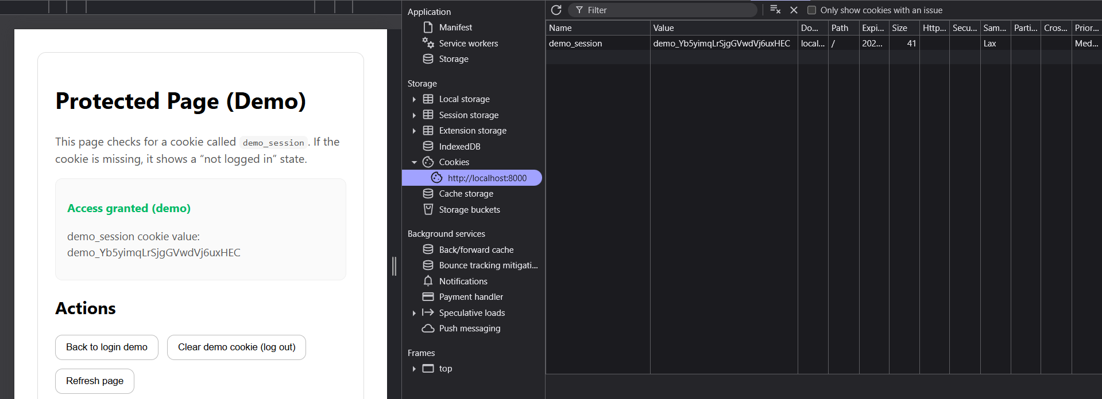
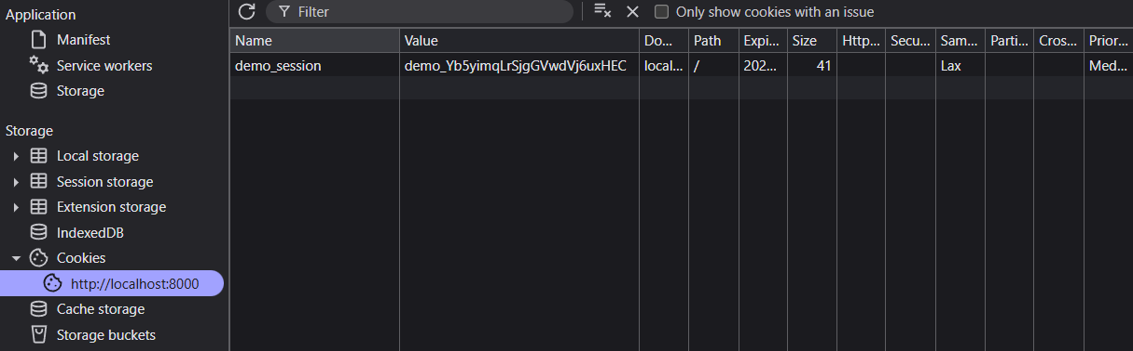
Explanation:-
The demo_session cookie stores a unique token value (like demo_Yb5yjmqLrSjgGVwdVj6uxHEC) that proves the user has successfully logged in. This session cookie is used by the server to identify and maintain the user's authenticated state across multiple page requests, so the user doesn't need to log in again on every page.

Part-C
Before the Deletion of the Cookie
After the Deletion of the Cookie
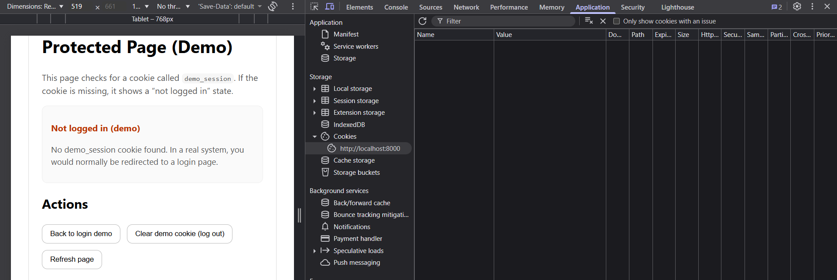

Explanation:-
After deleting the demo_session cookie, the page changed from "Access granted" to "Not logged in" upon refresh. This demonstrates that session management relies entirely on the presence of a valid cookie to determine whether a user is authenticated—the server trusts whatever cookie the client presents. Protecting session cookies is critical because if an attacker steals a valid session cookie (through XSS, malware, or network sniffing), they can impersonate the legitimate user without needing their password, effectively bypassing login entirely.

Part-5
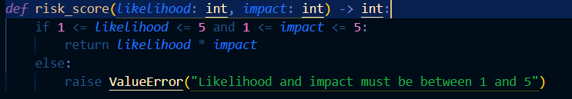
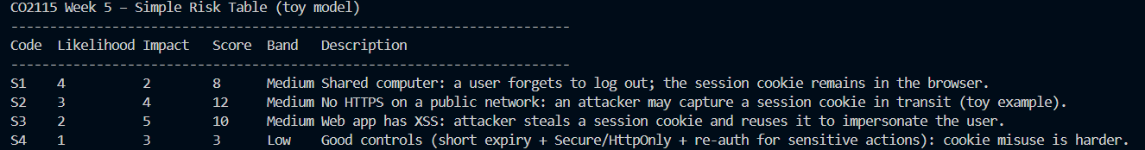
Scenario:-
"Shared computer: a user forgets to log out; the session cookie remains in the browser."
This directly reflects the hands-on demonstration where deleting the demo_session cookie immediately changed the protected page from "Access granted" to "Not logged in." The experiment showed that authentication state is determined solely by the presence of the session cookie—exactly the vulnerability described in S1. If a user forgets to log out on a shared computer, anyone who uses the browser afterward can access the account because the session cookie remains valid. This highlights why proper session management (like short expiry times and logout buttons) is essential for security.

Wrap-Up
Scope and authorization define the boundaries of a penetration test—scope specifies which systems and attacks are permitted, while authorization provides the legal permission to conduct the testing within those boundaries.
A proxy tool intercepts and displays HTTP traffic between browser and server, showing request details (URLs, headers, cookies, parameters) and server responses (status codes, response bodies, cookies), allowing testers to inspect and modify traffic manually.
Simple finding example:
- Evidence: The demo_session cookie persisted in the browser after closing and reopening the browser, and the protected page remained accessible without re-authentication.
- Explanation: The session cookie lacks an expiration timeout and persistent storage allows it to survive browser restarts, increasing the window of opportunity for theft or unauthorized reuse on shared computers.
- Risk rating: Medium
- Mitigation: Implement session expiration (e.g., 30 minutes of inactivity) and use "session" cookies that clear when the browser closes, or provide a "Remember me" option with explicit user consent.

